SR Snap Shot Tool

Pre Requisites

Limitations

Functionality Details

FAQ

Version Control

Pre Requisites

- Install Chrome browser.[ Snap shot Tool is currently only available for chrome web browser]
- Open any SR > Under the SR Details section> Set the sort: Created DESC Order And Save the Pref.
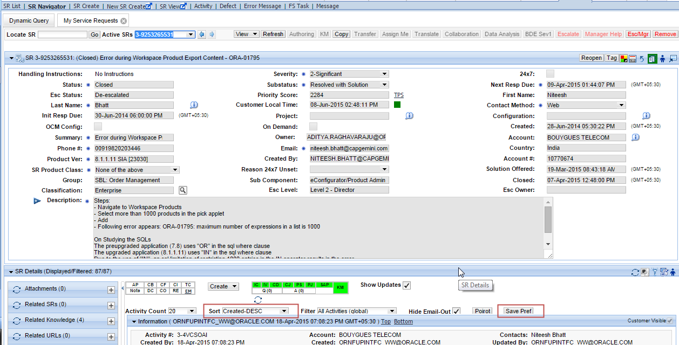

Limitations

- Do not use the Locate SR while doing SR review , instead provide /change the SR number directly in the Hyperlink to open an SR for review
  - https://support.us.oracle.com/oip/faces/secure/srm/srview/SRTechnical.jspx?action=createQueryTab&srNumber= 3-9253265531&rowIndex=3&listBcId=282-577&gridId=a4f41252-c207-4062-8663-128725ebf5e5&startIncludedRowIndex=0&calcCount=10&endOfSet=N#
  - This is because the DOM Objects are not refreshed, and the array still holds the previous SR values. Changing the SR Number in the hyperlink and hitting enter refreshes the entire web page.
- During the Review Process, please do not tab out / do any mouse scroll [Stay on the current SR page for getting accurate details].
  - Scroll top Method is used to do vertical scrolling on the Audit page, this method gets the current vertical position of the scroll bar; explicit scroll on your mouse interprets a wrong scroll position.
- Wait till the complete SR webpage is loaded before you click on SR Review Button.
  - Please view this Video to get more information
    - https://otube.oracle.com/media/How+to+Do+SR+Review+Using+SR+Snapshot+Utility/0_duavx3ot

Functionality Details

Header Bar Section Covers
- SR Number and the Summary of the SR
- Severity , If the SR is 24 /7 Enabled then you will observe the 24/7 Y Side to the severity
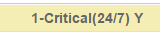
- Account Information
- Group in which this SR belongs to
- Total Age of the SR
- Total Customer Working Days
- Total Support Working Days
- Total Development Working Days

General Information Section Covers
- Current SR Status/Sub-Status
  - This gives information on the Current SR Status and its Sub status
- SR Owner
  - Gives the information of current SR owner
- Customer Email
  - Gives the information of current Email of the customer
- Account Classification
  - Is this classified as TOP ACCOUNT / Enterprise
- Any Severity Changes?
  - Mouse over gives the information of the Changes and the Days During the Life Cycle of the SR.
- NRD Missed
  - Details of NRD Missed with the respective SR Sub status
  - Acknowledgement time take to change the NRD expired value
- How NRD set?
  - List of NRD’s that are set during the life cycle of the SR[We are ignoring the negative values ] and considering only positive return values for ease of use.
  - Difference in Days and the respective SR Sub status during that time.
- No. of owners
  - Number of owners who are assigned with this service request
- #Transfers
  - Number of transfers that are made during the SR life Cycle
- Any Collaboration SRs?
  - Mouse over Lists the Collaboration SR’s associated with the SR
- Any Bugs Associated?
  - Mouse over Lists the BUGS which are associated with the SR
- Any Attachments?
  - Number of attachment associated with the SR and the respective file name details.
- Any KM?
  - KM Articles attached to the SR
- Root Cause?
  - This field gets populated mostly for the closed SR, which has a root cause given to it.
- Reason?
  - This field gets populated mostly for the closed SR, which has a Reason given while closing the SR.
- Know Issue?
  - This field gets Populated mostly for the closed SR, which has the details of know issue.

ODM Details Section Covers
- SR Snapshot Tool Captures the below ODM Tags and the date when it was done
  - Issue Clarification [IC]
  - Issue Verification [IV]
  - Cause Determination [CD]
  - Cause Justification [CJ]
  - Proposed Solution [PS]
  - Proposed Solution Justification [PSJ]
  - Solution Action Plan [SAP]
  - Question
  - Answer
- Mouse Over present the details of the content within the Tag,.

Escalation Details Section Covers
- SR Snapshot Tool Captures the below escalation details
  - Escalation Owner
  - Escalated After
    - Mouse over details provides the information of SR Escalation happened after how many days
  - Escalation level
  - CAM Engaged
    - Any Cam engagement happened on the SR.
- Communication with Customer
  - Before Escalation
    - Call Out Bounds – Calls Made by Support before SR escalation
    - Call In Bounds – Calls Made by Customer before SR escalation
    - Chat – Chat Instantiation done by customer / support before escalation
  - After Escalation
    - Call Out Bounds – Calls Made by Support After SR escalation
    - Call In Bounds – Calls Made by Customer After the SR escalation
    - Chat – Chat Instantiation done by customer / support After escalation

What does Communication Section Have?
    - Total Updates from customer Including attachment Updates
    - Number of ODM Action Plan tags posted by Support
    - Call In bounds, Number of Inbound calls received from Customer
    - Call Out Bounds, Number of Call Out bounds made by Support
      - Capture the Calls Made During which SR Sub status ?
      - Captures the Call Frequency and can be viewed on Mouse over
      - The Last record [Highlighted in the red]gives the First call made By Support after SR Creation date and the subsequent Call data list shows the Frequency between each call
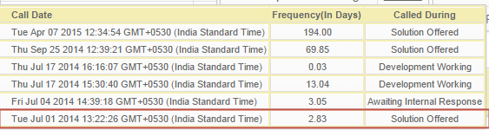
i.e 2.83 days we gave a call to customer for the first time and then again after 3.05 days [From the last call] we again engaged customer, then again after 13.04 days [From the last call i.e 3.05],
    - Chat Instantiation
      - All the mouse over details of chat is same like the call out bounds
    - Web Conferences
      - Tool Captures the WEBCONFERNCES made during the Life cycle of the SR
      - Code checks for any SR activity tags with below link information captures
Ex:
        - https://stbeehive.oracle.com/bconf/‘
        - https://oracle-swtsc-support.webex.com/‘

What does Warning Signal Section Have?
- Tool captures how many times the below Key Words are used by customer in their updates
  - ASAP
  - Business Critical
  - Critical
  - Go-Live
  - Any Update
  - Update me the Current Progress
- Mouse Over Details shows the Date when customer used this word & Respective SR Sub status & Last update from support when we received this signal & age of the SR during that signal time

What does Days Break up Section Have?
  - During the life cycle of the SR what is its days break up Age for each of the sub status
  - All the values shown here are in Days
  - Mouse over Details of each Hyper link value shows that date values from and to of the respective SR Sub status and the difference in days

FAQ

How SR Snap shot Tool is built?
- SR Snap shot tool is a Chrome Browser Extension built using j-Query and Chrome API to do web page scrapping .
- SR Snap shot Tool is a browser side script.

How does SR Snapshot Works?
- Scrapping the web page we take the necessary values from loaded SR web page.
- Pick and load the relevant data into a Arrays and variables
- Do the computation on the fly using j-Query.

Is there any security Breach?
- There is no Security Breach .Tool computes the logic on the fly,
- Code is a open source code, extension Package is specific to the users browser session.
- SR Snap shot is NOT COMMUNICATING to any 3rd part Severs.

How much time it takes to review an SR?
- As per MOS Current Functionality Audit Popup each time scroll fetches 25 rows of data.
- Ex: To Fetch 300 Rows we need 12 scrolls [300/25].
- Each scroll we have a timing interval of 9 seconds. As we have 47 Functions called during the each scroll execution.
i.e. 12* 9 = 108 seconds which is 1.8 minutes

After Hitting the Review Button nothing Happens
- After hitting the review button we would see auto scroll happening on the audit page , if that does not happen please check your VPN / Net work connection if there is break .
- Retry doing the review on a new tab
- If issue is consistent for all SR’s please contact Developer

Can I save the Web page
- Saving the Report Complete web page will not retain the HTML Page formatting
- You can ONLY save the report to a PDF Format

Can we get the extension for Fire Fox
- Currently we do not have the extension for Fire Fox.

Why am I seeing this message [Review for this SR is not done accurately the scroll position is interpreted wrongly from the audit pop up //Please review it manually//]
- During the process of reading the Audit popup data we see the Auto scroll position is interpreted wrongly because of changes in the SR description field , this causes the code logic to miss fire to calculate the SR Age details / NRD Details / Transfer details / Ownership details.

Where the data is fetched from?
- Audit Popup , SR Header Information
- SR Activities , Defects , Related SR’s

What are the Key areas covered during SR Snapshot Review?
- SR General Information
- ODM Details
- Escalation Details
- Communications
- Warning Signal
- Days Break

How to know which version of Extension you are using?
Under Chrome ://Extensions >version details
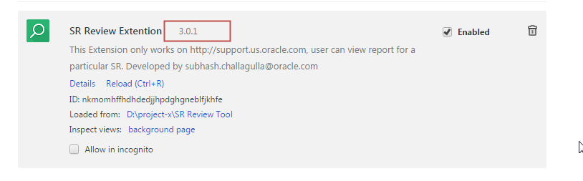

Version Control

Version 1.0.1 – Status [Completed] Packaged Date :May 29th 2015
- Framework of SR Snap shot tool to get data from MOS
- Chrome Browser Unpacked Extension
- Areas covered for Review
  - General Information
  - Escalation Details
  - ODM Details
  - Communications
  - Warning signals
  - Days Break Up

- Mouse Over’s Field Covered
  - Severity Changes
    - Severity changed from & To, After days
  - NRD Missed
    - NRD Changed by / Expired on /Modified On /Ack Time taken/ SR Sub status / Masked sub status
  - No of owners
    - Ownership of the SR’s – Email address of engineers
  - Collaboration SR’s
    - Collab SR details taken from Related SR section of SR Page
  - Bug Association details
    - Bug Details taken from Defects section of SR Page
  - Call Outbound
    - Call Date /Frequency /Sub status
  - ODM Tag Details
    - Text Used in ODM Tags
  - Escalation Level
    - Escalation Owner /Escalation Level /Escalated After
- Printing the data into HTML File
- Save to PDF
- Review SR from Hyperlink with SR number
Version 2.0.1 –Status [Completed] Packaged Date :June 9th 2015

- How NRD’s are set
  - Difference of Dates and the respective SR Sub status
- More Details of Warning Signals
  - For Warning Signal [All]
    - Warned On / From SR Creation Date(Days) / Sub Status/Last Activity By Engineer before signal(In Days)
- Days Break Up [All – Sub status]
    - Changed From / Changed To / In Days

Version 3.0.1 –Status [Completed] Packaged Date :July 13th 2015

- New Fields Added
  - Any KM?
  - Root Cause?
  - Reason?
  - Know Issue?
  - Customer Email
- Severity 1 24/7 Flag Check
- Modified the HTML Lay Out for General Information Header

